Chapter 5
Proposed avionics architectures for small aircraft
5.1 Introduction
5.2 Requirements of avionics data bus:
- Physical Requirements: The physical requirements specify the size, weight and power constraints of the networking equipment, as well as safety considerations relating to its operation and maintenance.

- Functional Requirements: The functional requirements relate to capability of the network in transporting data from source to destination and involve parameters such as throughput, latency, fault tolerance, bit-error rates etc.

- Environmental Requirements: The design of avionics system is affected by the environmental requirements, such as temperature, pressure, vibration and humidity.

- Cost and Life Cycle Requirements: These requirements relate to the maintainability, manageability, interchangeability, reliability and direct costs associated with network.

Considering above requirements we conclude that optical fiber based avionics databus can meet those requirements.

- Use of optical fiber data bus makes a reduction of size and weight because it is much lighter than copper coaxial wire. In page ( ) details are shown.
- The avionics data bus needs real time transmission and OFB\AD guarantees the high speed data transmission. Referring page no. ( ) for details.
- The temperature range of OFAD is -55 to +125°C , Humidity range is 4% to 98% RH which is satisfactory in aviation application. ^{[14][15]}
- Studies on reliability and MTBF of OFAD are showing promising results ^{[2]}
- We proposed our bus network with federated architectures.

5.3 Reason for selecting BUS network:

As explained in chapter ( ) there are different types of networks those we can use in avionics network. Choosing the basic network is the first and the most fundamental challenge faced by the designer. Considering the requirements of proposed architecture for small aircraft we select bus architecture. The reasons behind choosing bus architectures are given bellow:

- For small aircraft we need a network that is easy to use and understand. Bus topology fulfill that requirement
- For small aircraft avionics network less number of cable should be used. Bus topology also allows less number of cables in design.
- Redundancy is the most important factor in avionics network. Bus topology is the most redundant among all other topologies because the failure of a single device doesn’t bring the entire network.
- Bus topology is inexpensive and simple network.
- It is very easy to extend the network by adding cable with a repeater that boosts the signal and it allows it to travel a longer distance.

5.4 Reason for selecting Federated Architecture:
Different types of avionics architectures are explained in chapter ( ). Considering several aspects in design, including expected throughput, data flow patterns and for future expansion we choose federated architecture. All the facts behind selecting this architecture are given bellow:

- For small aircraft avionics architecture we need that the airborne systems are connected with each other through the standard data bus. Federated architecture fulfills that requirement.
- Sharing of information, simplification of interconnection between devices and reduction weight is necessary for small aircraft avionics architecture and these are the characteristics of federated architecture.
- Federated architecture permits the independent design, configuration and optimization of the major systems while ensuring they are using a common database.
- Sharing of the information and TDMA used in federated architecture saves hundreds of pounds of wiring.
- As our proposed data bus works on digital format and optical fiber is used as transmission medium, federated architecture supports both of them.
- System software and hardware changes are easy to make.
- Failure is not propagated.

5.5 Avionics components selected for small aircraft:
For single engine small aircraft we propose the following avionics equipments:
- Master computer
- Backup Master computer
- Inertial navigation platform
- Multifunction display
- ADC
- GPS
- Engine Monitoring unit
- Radio Navigation Aids

5.5.1 Master computer: The master computer is a key part of the data bus system. The functions of the master computer are constant monitoring of the data bus and the traffic on the bus. It controls the data flow of the bus. There is only one master computer in aircraft and it situated on the belly of the aircraft.

5.5.2 Backup Master computer: The job of backup master computer is same as master computer but it will only activate when the master computer fails. It increases the redundancy of the system and sometimes help master computer.

5.5.3 Inertial navigation platform^{[16]} : An inertial navigation platform is a navigation aid that uses a computer, motion sensors (accelerometers) and rotation sensors (gyroscopes, in our small engine aircraft laser gyro to continuously calculate via dead reckoning the position, orientation, and velocity of aircraft without the need for external references. The block diagram of inertial navigation platform is shown in figure (5.1)

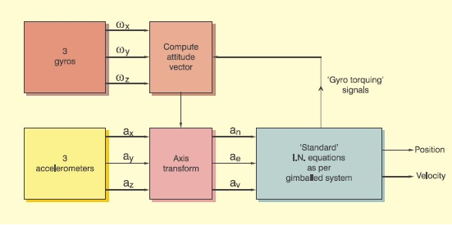

Figure 5. 1: Inertial navigation platform

In our proposed databus laser gyro is as the main equipment of inertial navigation platform. Laser gyroscope consists of a ring laser having two counter-propagating modes over the same path in order to detect rotation. It operates on the principle of the Sagnac-effect which shifts the nulls of the internal standing wave pattern in response to angular rotation. Interference between the counter-propagating beams, observed externally, reflects shifts in that standing wave pattern, and thus rotation. Laser gyroscopes can be used as the stable elements (for one degree of freedom each) in an inertial reference system. The advantage of using it is that there are no moving parts (shown in figure 5.2). Compared to the conventional spinning gyroscope, this means there is no friction, which in turn means there will be no inherent drift terms. Additionally, the entire unit is compact, lightweight and virtually indestructible, making it suitable for use in aircraft. Unlike a mechanical gyroscope, the device does not resist changes to its orientation.
5.5.4 Multifunction display: A multi-function display (MFD) is used to display information to the pilot in numerous configurable ways. Often an MFD is used in concert with a primary flight display. MFDs are part of the digital era of modern aircraft. The advantage of an MFD over analog display is that an MFD does not consume much space in the cockpit that’s why we are using in our small engine aircraft. MFD allows the pilot to display their navigation route, moving map, weather radar and other information related to flight and equipments.

Figure 5.2: Laser gyroscope Figure 5.3: Multifunction display
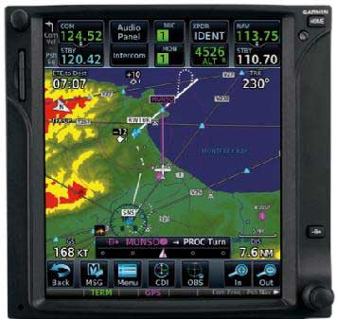
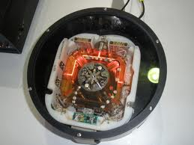

5.5.5 ADC: An Air Data Computer (ADC) is a computer that is used to acquire and process data from different sensors to obtain parameters such as airspeed, altitude, temperature, angle of attack etc.
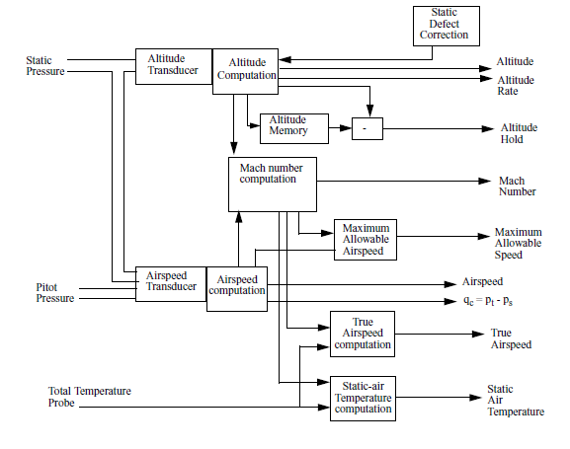
Its inputs are pitot and static pressure tubes, a temperature probe signal, a barometric setting and various aircraft configuration discrete like flap deployment. Static and impact pressure transducers are used in pressure tubes. Then inputs go to input processing unit. Here input data is processed. After processing input data, data flows through internal bus and then it is stored in memory. There is output processing unit which processes data and finally gives parameters^{.[18][19]} . The block diagram ^{[25]} of ADC is shown in figure 5.4.

Figure 5.4: Block diagram of Air data computer.

5.5.6 GPS: GPS (Global Positioning System) is basically ranging system. GPS offers an inexpensive and reliable supplement to existing navigation techniques for aircraft. With GPS, an aircraft's computers can be programmed to fly a direct route to a destination. The savings in fuel and time can be significant.GPS can simplify and improve the method of guiding planes to a safe landing, especially in poor weather. With advanced GPS systems, airplanes can be guided to touchdown even when visibility is poor. For the pilot, GPS systems provide position information in a practical, simple, and useful form. Pilots often rely on GPS to navigate to their destinations. A GPS receiver in the cockpit provides the pilot with accurate position data (latitude and longitude) and helps him or her keep the airplane on course.

5.5.7 Radio Navigation Aids:

A navigational aid is any sort of marker which aids the traveler in navigation. We propose that aircraft must have following radio navigation aids:

- ILS
- VOR
- DME

The description of these equipments is given bellow:

ILS: An instrument landing system (ILS) is a ground-based instrument approach system that provides guidance to an aircraft approaching and landing on a runway. ILS components are localizer, glide slope, marker beacons.
An ILS consists of two independent sub-systems, one providing lateral guidance, the other vertical guidance to aircraft approaching a runway. There is a localizer antenna array. Two signals modulated at 90 and 150 MHz are transmitted from separated but co located antennas. The localizer receiver on the aircraft measures the difference in the depth of modulation (DDM). If there is a predominance of either 90 Hz or 150 Hz modulation, the aircraft is off the centerline. In the cockpit, the needle on the horizontal situation indicator shows that the aircraft needs to fly left or right to correct the error to fly down the center of the runway. Same way it also provide safe decent angle landing facilities to pilot ^{[20]}

VOR: VHF Omni-directional Radio Range, popularly known as VOR, is a short range navigation aid operating in the VHF band of the radio spectrum. It is practically free from static and night effect therefore is a reliable navigational aid by day and night. The signal transmitted by the VOR contains directional information. It provides bearing information in form of radials and magnetic bearings to the station throughout 360° of the ground transmitter. Operating principle of VOR is bearing by phase comparison.

DME: DME means Distance Measuring Equipment. It is used to measure distance of aircraft from the station. It is a transceiver. It transmits signal in all directions. Signal is received by a DME ground station. Station receives the signal and again transmits. The signal is again sent back to the transceiver. The transceiver measures the time it takes for the signal to be sent and a reply to be received. The interval between the transmission and the reception provides the aircraft with the real distance information from the ground station. This information displays on the multifunction display in the cockpit. ^{[22]}

5.5.8 Engine control system: Engine control system consists of the equipments that measure engine temperature, exhaust gas temperature and engine rpm. Different types of temperature sensors like thermostat and semiconductor temperature transducer are used to measure the temperature of engine and exhaust gas temperature and tachometer is used to measure rpm.

5.6 Proposed Optical fiber based Avionics databus for a small aircraft

Our proposed avionics architecture is based on bus network and federated architecture. All equipments generates electrical signal, Electrical to Optical converter covert the electrical data in optical form and transmit in data bus. The signal coding is Manchester bi-phase. Logical 1 begins with optical energy present, which is then turned off at mid-bit. Similarly, a logical 0 begins without optical energy, which is then turned on at mid-bit. It is not necessary to know the polarity of the sent signal since the information is not kept in the actual values of the voltage but in their change, in other words it does not matter whether a logical 1 or 0 is received, but only whether the polarity is the same or different from the previous value; this makes synchronization easier. It is a full duplex communication, transmit and receive in same optical fiber. Bus traffic or data throughputs travels along the bus in words. A word in our proposed databus is a sequence of 16 bits consisting 1 bit synchronization, 14 bits of data and one parity check bit. The sync and parity bit are added before transmission and remove them during reception. Therefore the nominal word size is 14 bits with the most significant bit (MSB) first. There are two types of words: command word and data word.

5.6.1 Command word: Command words are generated by the every equipment of databus. It consists of 16 bits with recipient address, sender identification and data word count. In figure 5.5 Command word is shown.

- Command word got 1st 2 bits for synchronization and last bit for parity checking.
- 4 bits for source identification
- 4 bits for Recipient identification.
- 1 bit for transmitting or receiving operation.
- Data word count is 4 bit so after every command word one equipment can transmit maximum 2⁴ =16 data word

2 bits | Sender identification-4 bit | 1 bit | Recipient identification-4 bit | Data Word count  4 bit | 1 bit

Synchronization Rx/Tx parity
Figure 5.5: Command word

5.6.2 Data word: Data word follows the command word sent by any equipment. It consists of 16 bits. Data word only transmits data bits. In Fig: Data word is shown in figure 5.6. It consists of
- 1 synch. Bit
- 1 parity bit.
- 14 bits for data bit.

Sync  1bit | DATA 14 bit | Parity  1bitt

Figure 5.6: Data word

Command word has 4 bits for recipient address so it can support 2⁴=16 equipments. It has 4 bits for data word count so one equipment can talk max 2⁴ =16 words each time. The small message size results in very low latency, minimizing delays during processing and guaranteeing timing, as no transport side queuing or rescheduling of traffic can happen. The message size is one of the cornerstones for achieving safety, resilience and reliability [12].
If two or more nodes start transmitting at the same time, the bus conflict will be resolved by an arbitration using the identifier and the lowest identifier transmission will be delayed. ^{[7]} in fig (5.2 ) the process is shown .Table 5.1 shows proposed addressing of various avionics equipments.

Redundancy is the most important factor in aviation sector. High availability environments also require redundancy on the bus as well as within equipments. To improve the reliability dual redundant optical databus is used. Every equipment connected with both of them. In case of failure of one bus, other can support the system.

Priority | Component | Memory address
1 | Master Computer | 0000
2 | Backup Master Computer | 0001
3 | Laser gyro | 0010
4 | Air Data Computer | 0011
5 | Engine Monitoring System | 0100
6 | GPS | 0101
7 | Multifunction Display | 0110
8 | Radio Navigation aids | 0111

Table 5.1 : priority of the equipments
Initially transmitted data from any equipment

Identify the sender

Is the sender priority is greater?
Greater ?
No

Delay
Yes

Complete the process

Fig 5.7: Priority allocation of proposed data bus

Multifunction Display or Display Map Bank
Electrical to Optical Converter & Optical to Electrical converter (Transceiver)
Data Transmission in Optical form same wave length “λ”
Data Bits in Electrical Form
Laser Gyro Or Inertial Navigation Platform
Engine Control System
Radio communication set
Master Computer
GPS
Backup Master Computer
ADC

Data bus

Figure 5.8 : Proposed Optical Databus Architecture for a small aircraft

